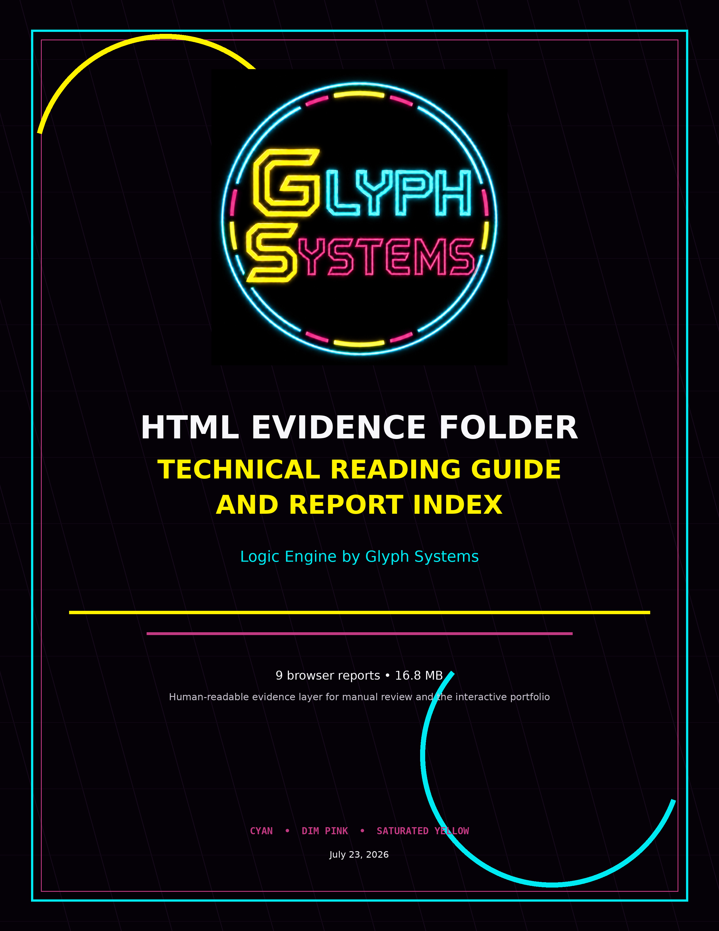

HTML Evidence Folder — Technical Overview
What the nine browser reports contain, how to read them, and how to distinguish primary evidence from milestone, historical, and startup-only records.
Purpose. This document is the standalone guide for the HTML Files folder. It is intended for a reviewer who wants to understand the reports without using the interactive portfolio.
Folder summary. The folder contains 9 self-contained HTML reports totaling approximately 16.8 MB. The files cover Programs 34, 35, 36, 38, 40, 41, and 42. They include one historical seven-hour continuity report, five meaningful twelve-hour milestone or endurance reports, and two zero-round startup/preflight exports.
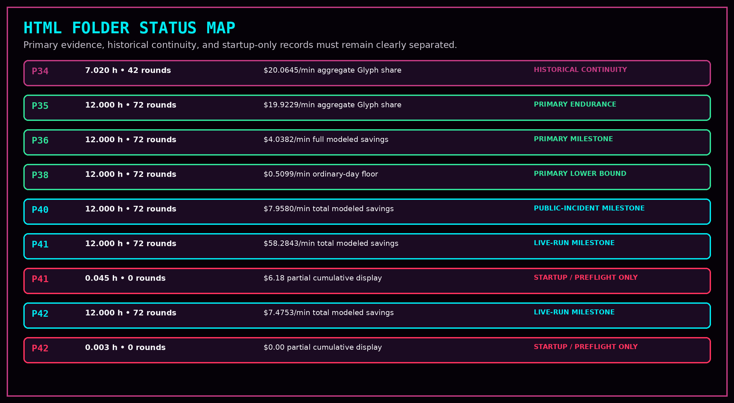
The HTML folder is the human-readable presentation layer. It does not contain the complete raw-data, manifest, hash, or source-code record.

1. How to Read Every HTML Report
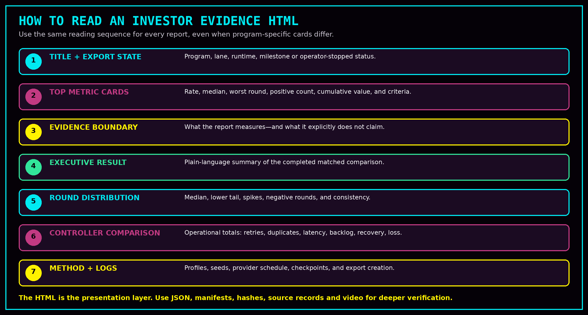
- Confirm the export state first: milestone, endurance, or operator-stopped startup.
- Read runtime and complete-round count before interpreting any dollar-per-minute card.
- Use the median, lower tail, worst round, and positive-round count—not only the average.
- Read the evidence boundary before treating any modeled value as commercial performance.
- Use the controller comparison to understand the operational source of the modeled difference.
- Open the deeper PROGRAMS DOC INFO folder for JSON logs, manifests, hashes, frozen public inputs, and chain-of-custody review.
A browser report makes the evidence understandable. It does not by itself establish realized customer savings, collected revenue, independent validation, or production deployment.

2. Recommended Manual Reading Order
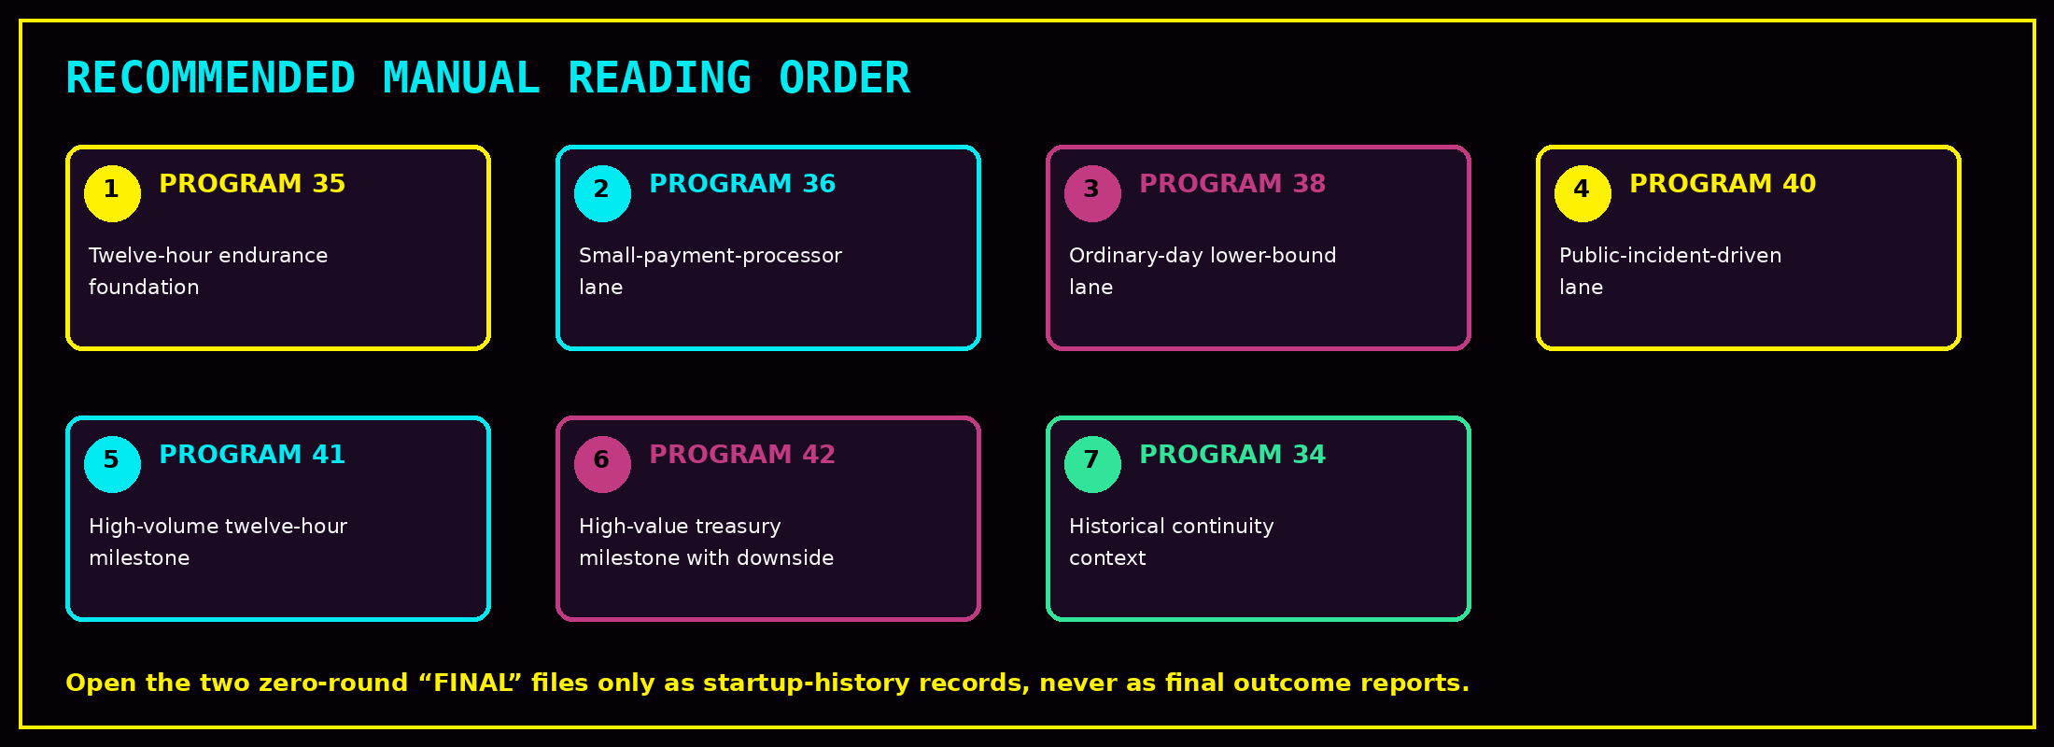
This sequence begins with the clearest completed endurance record, then moves through increasingly specialized lanes. Program 34 is useful historical context but uses earlier naming and commercial-display conventions.

3. Complete HTML Report Index
Pgm | File | Runtime | Displayed rate | Classification | Technical use
34 | PROGRAM_34_INVESTOR_EVIDENCE.html | 7.020 hours / 42 complete rounds | $20.0645 / min | Historical continuity evidence | Seven-hour continuous run with 42 complete rounds. Preserves earlier Logic Engine + Fibrologic naming and a 50% modeled share presentation.
35 | PROGRAM_35_INVESTOR_EVIDENCE.html | 12.000 hours / 72 complete rounds | $19.9229 / min | Primary endurance evidence | Completed twelve-hour endurance run with 72 complete rounds and a preserved controlled-evidence boundary.
36 | PROGRAM_36_12H_MILESTONE_INVESTOR_EVIDENCE.html | 12.000 hours / 72 complete rounds | $4.0382 / min | Primary milestone evidence | Twelve-hour small-payment-processor milestone using full modeled savings before commercial allocation.
38 | PROGRAM_38_12H_MILESTONE_INVESTOR_EVIDENCE.html | 12.000 hours / 72 complete rounds | $0.5099 / min | Primary lower-bound milestone | Ordinary-day floor run with no burst-saturation rounds, designed to test the signal under mostly normal operating conditions.
40 | PROGRAM_40_12H_MILESTONE_INVESTOR_EVIDENCE.html | 12.000 hours / 72 complete rounds | $7.9580 / min | Primary external-input milestone | Public-incident-driven medium-financial run using a frozen incident schedule. Includes a historical illustrative 35% Glyph Systems cut.
41 | PROGRAM_41_12H_MILESTONE_INVESTOR_EVIDENCE.html | 12.000 hours / 72 complete rounds | $58.2843 / min | Primary live-run milestone | Twelve-hour high-volume payment-network milestone. The longer Program 41 run continued after this export.
41 | PROGRAM_41_FINAL_INVESTOR_EVIDENCE.html | 0.045 hours / 0 complete rounds | $2.3154 / min | Startup / preflight record only | Operator-stopped after approximately 0.045 hours with zero complete rounds. Retain for history, but do not present as final long-horizon evidence.
42 | PROGRAM_42_12H_MILESTONE_INVESTOR_EVIDENCE.html | 12.000 hours / 72 complete rounds | $7.4753 / min | Primary live-run milestone | Twelve-hour treasury and cross-border payout milestone. Preserves both positive aggregate results and meaningful negative-round downside.
42 | PROGRAM_42_FINAL_INVESTOR_EVIDENCE.html | 0.003 hours / 0 complete rounds | $0.0000 / min | Startup / preflight record only | Operator-stopped after approximately 0.003 hours with zero complete rounds. Retain for history, but do not present as final long-horizon evidence.
PROGRAM_41_FINAL_INVESTOR_EVIDENCE.html and PROGRAM_42_FINAL_INVESTOR_EVIDENCE.html are zero-round startup records. Their filenames must not be used to imply completed final evidence.

4. Programs 34 and 35 — Historical Continuity and Endurance Foundation
Program | Runtime | Displayed rate | Median | Worst | Interpretation
34 | 7.020 h / 42 rounds | $20.0645/min aggregate Glyph share | $4.8222/min | $0.5340/min | Historical seven-hour continuity evidence. Preserves earlier Logic Engine + Fibrologic wording and a 50% modeled-share presentation.
35 | 12.000 h / 72 rounds | $19.9229/min aggregate Glyph share | $4.8835/min | $0.2084/min | Primary twelve-hour endurance foundation. Shows 57 of 72 rounds at or above $1/min and cumulative modeled advantage of $28,688.95.

- Program 34 is valuable as development history and continuity evidence, but its public naming is older than the current Glyph Systems portfolio language.
- Program 35 is the clearest complete twelve-hour endurance report in the folder.
- Both reports use aggregate Glyph-share displays rather than the later full-modeled-savings-first convention.
- Neither report represents realized customer revenue.

5. Programs 36 and 38 — Small Processor and Ordinary-Day Floor
Pgm | Runtime | Rate | Median | Worst | Positive | Interpretation
36 | 12.000 h / 72 | $4.0382/min | $1.0593/min | $0.0641/min | 19/72 >= $2/min | Conservative small-payment-processor milestone. Displays full modeled savings before allocation.
38 | 12.000 h / 72 | $0.5099/min | $0.3464/min | -$0.0002/min | 71/72 positive | Ordinary-day lower-bound milestone with burst-saturation excluded by design.

- Program 36 asks whether a positive signal remains in a smaller processor profile.
- Program 38 asks whether the signal survives ordinary operating conditions rather than depending on severe events.
- The nearly zero negative worst round in Program 38 should remain visible because it shows downside was preserved.

6. Program 40 — Public Incident-Driven Medium Financial Milestone
Program 40 is the first report in this folder whose severity schedule is shaped by a frozen snapshot of official public incident records. The report remains a controlled matched benchmark; the public records do not reproduce private provider traffic, losses, or recovery systems.
Field | Report value
Runtime | 12.000 hours / 72 complete rounds
Total modeled savings | $7.9580 per minute
Median / worst | $3.1991 per minute / -$0.0442 per minute
Positive rounds | 71 of 72
Cumulative modeled savings | $5,729.77
Commercial display | Historical illustrative 35% Glyph Systems cut; not contractual
Correct use | External-input-shaped milestone evidence with a preserved evidence boundary
The current commercial model is documented separately. Preserve the historical 35% display as evidence history, but do not treat it as the current standing split.

7. Programs 41 and 42 — Live-Run Milestones and Startup Records
Pgm | Record | Runtime | Rate | Median | Worst / positive | Correct classification
41 | 12H milestone | 12.000 h / 72 | $58.2843/min | $8.8897/min | $1.3129 / 72 of 72 | Valid contained milestone; the longer run continued after export.
41 | “Final” startup | 0.045 h / 0 | $2.3154/min | $0.0000/min | 0 / 0 | Startup/preflight only; partial live card, no completed-round outcome.
42 | 12H milestone | 12.000 h / 72 | $7.4753/min | $1.6210/min | -$3.3787 / 45 of 72 | Valid contained milestone with significant preserved downside.
42 | “Final” startup | 0.003 h / 0 | $0.0000/min | $0.0000/min | 0 / 0 | Startup/preflight only; no completed-round outcome.

- The milestone and startup files are separate executions, not one continuous seed.
- The Program 41 milestone is positive in all 72 completed rounds.
- The Program 42 milestone is positive in aggregate but has a negative lower tail and only 45 positive rounds out of 72.
- When Programs 41 and 42 are stopped on camera, their new final exports should be added as new files rather than overwriting these milestones.
The startup files are still useful for provenance and troubleshooting history. Their correct label is STARTUP / PREFLIGHT RECORD, not FINAL LONG-HORIZON RESULT.

8. What the HTML Folder Does—and Does Not—Contain
Contained in this folder | Located elsewhere
Self-contained browser reports | Full RUN_LOGS JSON
Executive summaries and evidence boundaries | Package manifests and SHA-256 file maps
Metric cards and distribution charts | Frozen public incident snapshots
Controller comparisons | Program source and private source verification
Method descriptions | Screenshots and video evidence
Embedded run logs or selected event summaries | Interactive browser navigation program
Historical commercial-display language | Independent customer-pilot validation
This folder is designed for quick human review. The PROGRAMS DOC INFO folder is the deeper technical evidence layer.

9. Correct Evidence Boundaries and Non-Claims
Boundary | Correct interpretation
Modeled values | Controlled estimates under the report’s declared harness and cost model; not guaranteed liquid cash.
Customer revenue | No HTML in this folder proves invoiced, collected, or independently verified customer revenue.
Named systems | The reports do not claim access to named banks, payment networks, treasury platforms, or private production systems.
Public incidents | They shape a frozen reproducible schedule where used; they do not reproduce provider-private operations.
Commercial split | Displayed percentages are illustrative or historical planning values unless governed by a separate written agreement.
Negative rounds | Negative and near-zero rounds are evidence and should remain visible.
Security / compliance | The reports do not by themselves establish production security, regulatory compliance, or audit certification.
Next gate | Independent technical review and an authorized read-only customer shadow pilot using pre-agreed measurement rules.
Core claim: the HTML folder presents repeated controlled signals and milestone evidence in a form that a nontechnical reviewer can understand.

10. Reviewer Checklist and Final Interpretation
Check | Question
File identity | Did I open the intended program and export state?
Runtime | How long did the run operate, and how many complete rounds exist?
Distribution | What do the median, lower tail, worst round, and positive count show?
Evidence boundary | What does the report explicitly exclude?
Commercial display | Is the percentage current, historical, or merely illustrative?
Input source | Was the schedule controlled, ordinary-day, or shaped by frozen public incidents?
Deeper evidence | Do I need the matching JSON logs, manifest, snapshot, screenshot, or video?
Classification | Is this primary evidence, historical continuity, milestone evidence, or startup/preflight history?

Final interpretation
The HTML Files folder is the manual reading layer of the Logic Engine evidence portfolio. It lets investors, business reviewers, and technical evaluators open each report directly in a browser without the interactive program.
The strongest current manual sequence is Program 35, Program 36, Program 38, Program 40, Program 41 twelve-hour milestone, and Program 42 twelve-hour milestone. Program 34 adds historical continuity. The two zero-round “FINAL” files remain startup records and must be labeled accordingly.

